Abstract
The goal of this project is to create a model that will classify a song’s genre.

Dataset
The data for these songs comes from The Echo Nest.
“The Echo Nest is a music intelligence and data platform for developers and media companies.” (Wikipedia)
I merged two datasets, tracks and echonest_metrics, based on the track_id column to combine the track metadata with the corresponding audio features. This step created a new dataframe, echo_tracks, that contains both the genre labels and the audio features for each track.
echo_tracks.head()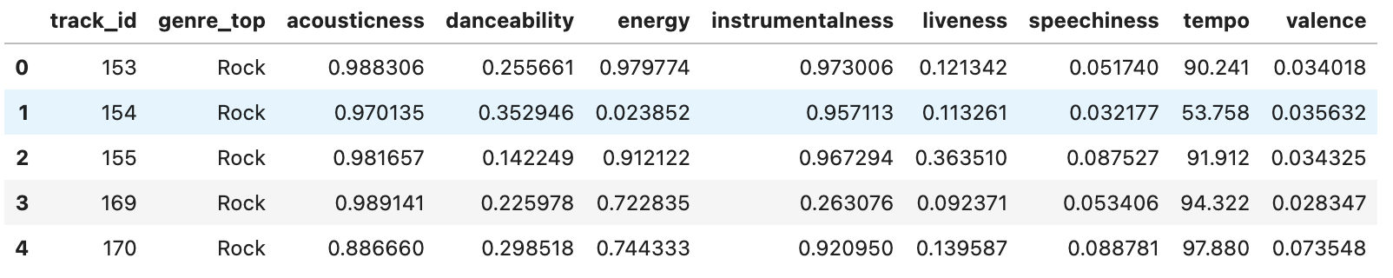

Exploratory Data Analysis
echo_tracks.corr()
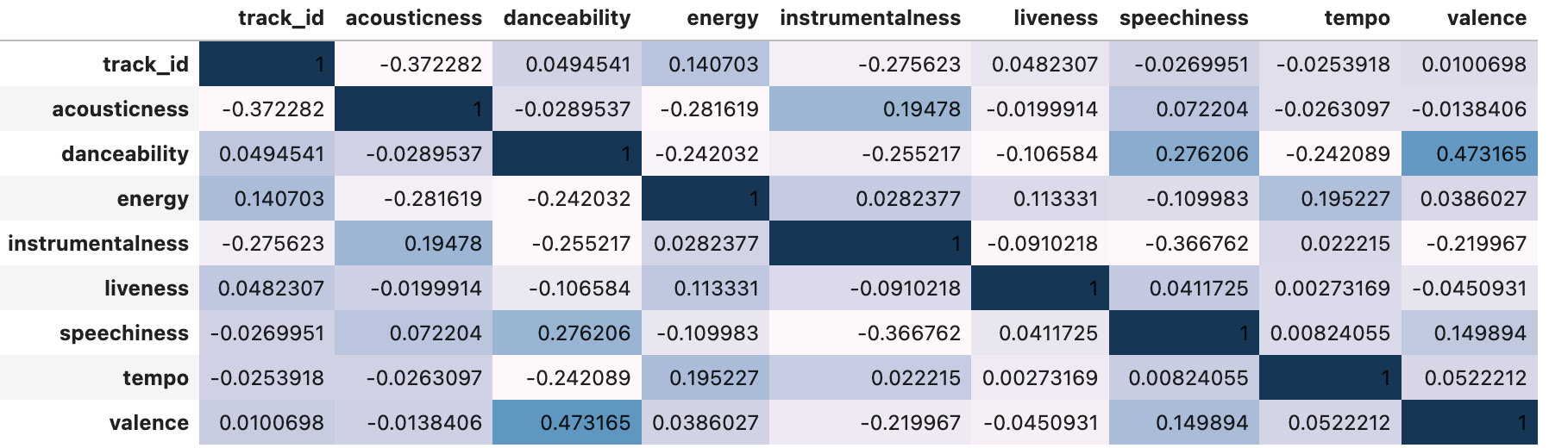
There’s some correlation between valence and danceability, but not much.

Feature Engineering
I standardized the selected audio features using the StandardScaler from scikit-learn. This step normalized the features to have a mean of 0 and a standard deviation of 1, which can improve the performance of machine learning models.
I applied Principal Component Analysis (PCA) to reduce the dimensionality of the standardized features. PCA is a technique that transforms the data into a new coordinate system where the greatest variance lies along the first coordinate (the first principal component), the second greatest variance lies along the second coordinate, and so on. By selecting only the top few principal components, I can reduce the number of features while preserving most of the information in the data.

Model Training
Train-Test Split: I split the data into training and test sets using train_test_split from scikit-learn. This step ensured that I evaluated the models on data that they were not trained on.
Decision Tree and Logistic Regression: I trained two machine learning models, a decision tree and a logistic regression model, to classify the tracks as either rock or hip-hop. These models were trained on the projected features obtained from PCA.
Evaluation Metrics: I evaluated the performance of the models using accuracy scores, confusion matrices, and classification reports. These metrics provided insights into the ability of the models to correctly classify the tracks.
About Decision Tree and Logistic Regression
Logistic Regression is a statistical model that predicts the probability of a binary outcome based on a set of independent variables.
Decision Trees are tree-like structures that represent a set of decisions and their possible consequences.
Conclusion
This project demonstrates a comprehensive approach to music genre classification using machine learning algorithms. The decision tree and logistic regression models achieved good accuracy on both balanced and imbalanced datasets, suggesting they can generalize well to unseen data. Feature engineering and model selection are key to accurate genre classification.

